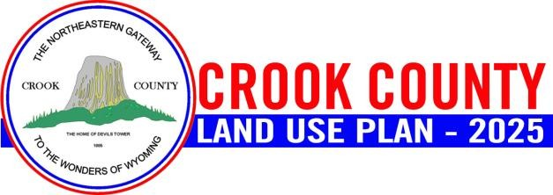

CROOK COUNTY LAND USE PLAN UPDATE STEERING COMMITTEE
MEETING

September 10, 2025
3:00 PM
County Commissioners Meeting Room County Courthouse
309 E. Cleveland St., Sundance

Join the meeting now Microsoft Teams Need help?
Join the meeting now
Meeting ID: 254 486 855 348 6
Passcode: ZS9u4cC7

AGENDA

- Welcome and Roll Call

- Public Outreach Strategy – Bree Burton

  - Review the document and add any additional strategies

- Citizen Survey – Bree Burton
  - Review cost estimate for mailing – estimated cost $19,748.50 just for postage, additional $2,500 for labor to put together and print
  - Review Number of Completed Surveys Needed – 367 surveys
  - Review questions
  - Review outreach strategies
    - Review survey link online - Crook County Land Use Plan Update | Houston Engineering
    - Add primer information to on website
  - Review timeline
    - Edits to survey by Friday at noon.
    - Mailers in tax bills go out next week
    - Survey flyer/advertisement to steering committee by Tuesday 9/16
    - Survey to go live by Wednesday, 9/17
    - Newspaper/Social media week of September 22nd
      - Will continue to push social media
    - Close Survey – tentatively run for 30 days, Friday October 17th. If we aren’t getting our numbers we may need to push it a couple of weeks.

- Stakeholder Interview Status – Michael Surface

  - Continuing stakeholder outreach through September
  - Y2 will provide a summary of stakeholder interviews by the October meeting.

- Guidance vs. Regulation – if time allows
- Review Raw Stakeholder Interviews – if time allows

- Questions & Comments

- Next Steering Committee Meeting

  - Currently scheduled for Wednesday, October 15, 2025 3-5 PM; request moving to Wednesday October 29, 2025 from 3-5 PM due to scheduling conflicts for Bree
    - Pushing back a little will allow us to get the stakeholder summary finished and out ahead for review and will allow survey results to be presented to the SC and trends and conditions draft to be presented to SC.

